Your Guide for

16 Days of Activism Again Gender-Based Violence 2021

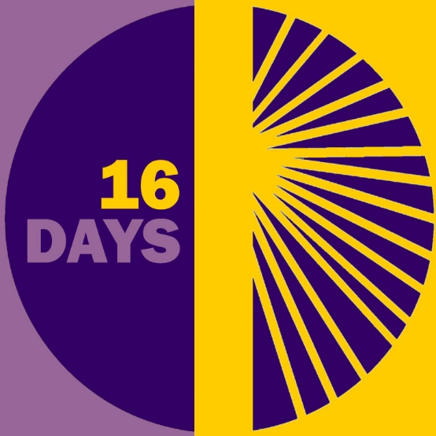

Introduction

At Mothers’ Union we have a vision of a world where everyone can prosper and reach their full potential. We believe that all people are created in the likeness of God and deserve to be treated as God’s precious children.

Sadly we know that this is not the daily reality for many who are experiencing or have experienced violence or abuse. Abuse has a detrimental long-lasting impact on the survivor and their family and children. This impact, which can be mental, emotional, physical, social, financial and/or spiritual, is far from the abundant life that God intends for all through Christ.

As followers of Christ, we are called to love our neighbour as ourselves. Through our prayers and actions, we are therefore compelled to support those experiencing violence and abuse and take action to stop it before it starts. It is only in each of us playing our part that we can strive to achieve our vision and create a world where God’s love is shown and known through loving, respectful and flourishing relationships.

The UN 16 Days of Activism on Gender-Based Violence is an opportunity for Mothers’ Union members to express this love in action. This guide and its accompanying resources aim to equip Mothers’ Union members to take action and mobilise others to act too. The guide outlines what 16 Days of Activism is about, how you can take action and what resources will be available to support you in this, and how to tell us how your action went.

Throughout this guide, the term ‘gender- based violence’ will refer to men’s violence against women. See ‘Key terms’ for a definition. Whilst men and women can experience violence and abuse, the global evidence base shows us that majority is carried about by men against women. This is therefore where we need to focus our efforts for change in particular and why the UN’s 16 Days campaign has this focus. See ‘Key facts and figures’ resource for more information.

About 16 Days of Activism

16 Days of Activism against Gender-Based Violence is a global campaign calling for an end to violence against women and girls. Every year, it begins on the International Day for the Elimination of Violence Against Women (25 November) and ends on International Human Rights Day (10 December). During this time, organisations and individuals from around the world raise awareness about violence against women in all its forms and call for change. Campaigns like this one aim to highlight the need for us all to play our part in supporting survivors and preventing gender-based violence within our society.

The 16 Days campaign is an extension of the day-to-day grassroots work of Mothers’ Union. We work alongside communities to help end gender-based violence and to support those affected by it every day of the year.

Take Action

Pray

Set aside time each day during the 16 Days of Activism to reflect and pray about gender-based violence. The prayer diary provides short daily reflections and prayers to help us increase our understanding about gender-based violence, pray for those affected by it, and equip us to take a stand for change.

- Get your prayer diary on the Mothers’ Union 16 Days webpage.

- Share it with others and invite them to join you in prayer.

Additional resources:

- You will find more worship and prayer resources on gender-based violence on the Mothers’ Union 16 Days webpage.

Host or attend an event for Mothers’ Union’s Global Day of Action

Mothers’ Union will be holding a Global Day of Action on Saturday 27 November.

We are building on last year’s campaign, focusing on the theme of #nomore1in3 (no more 1 in 3) because 1 in 3 women will be impacted by some form of violence in their life and we believe this is unacceptable.

Take part by hosting or attending an event on the day. There are three ways you can be involved:

- BIG
Hold an event at your Cathedral. We hope this event will be held at cathedrals in at least 15 dioceses across Britain and Ireland, with as many members as possible, plus clergy and other local high-profile individuals. Speak with you Diocesan President to see what the plans are in your area or to maybe lead on this!

- LOCAL
Organise an event at a local level, perhaps in your branch or deanery. You could also ask other local groups to get involved.

- HOME
If you can’t join an outside event, why not join in fellowship with those from your own home?

As part of the day, we invite you to wear a purple scarf and to stop for a three-minute silence at 1.03pm (linking to the 1 in 3 theme).

More information and resources to help you run an event will be available on the Mothers’ Union website closer to the date: www.mothersunion.org/global-day-2021.

Let us know what you are doing!

Together we want to get those who make the decisions on funding, support and services to sit up and listen. Let us know what you are planning – big or small! Complete this simple online form https://bit.ly/GlobalDayEvents or let your Diocesan President know so that they can collate and share with Mary Sumner House. This will help us to try and secure national press coverage.

Learn more

Dedicate time to learning more about gender-based violence during 16 Days using the resources provided.

- Get the ‘Facts and figures’ information sheet on the Mothers’ Union 16 Days webpage and order a copy of Restored’s Ending Domestic Abuse: A Pack for Churches.

- Share the resources with others in your Mothers’ Union group and invite them to learn more with you.

Additional resources:
- You will find more resources to help you learn about gender-based violence, including on theology, on the Mothers’ Union 16 Days webpage.

Tell us how it went

We would love to know what you did for 16 Days and how it went. This will help us to tell the story about how Mothers’ Union members are making a positive difference. It will also enable us to learn what went well, what went less well, and what we could do better next time to support you.

Please set aside some time after 16 Days to share your reflections and feedback with us, using this online survey.

Key terms

These terms are used throughout this guide, with definitions listed below.

Domestic abuse

Domestic abuse is an incident or pattern of incidents of controlling, coercive, threatening, degrading and violent behaviour, in the majority of cases by a partner or ex-partner, but also by a family member or carer. In the vast majority of cases it is experienced by women and is perpetrated by men. Domestic abuse affects people from all walks of life, regardless of age, social class, level of education or income, ethnicity, disability or lifestyle.

Domestic abuse can include, but is not limited to, the following:
- Coercive control (a pattern of intimidation, degradation, isolation and control with the use or threat of physical or sexual violence)
- Psychological and/or emotional abuse
- Physical or sexual abuse
- Financial or economic abuse
- Spiritual abuse
- Harassment and stalking
- Online or digital abuse

Gender-based violence

Gender-based violence (GBV) includes all forms of violence and abuse carried out against someone based on their gender, or violence and abuse that affects people of a gender disproportionately. It is most frequently used to describe men’s violence against women.

GBV can take many forms, including sexual, physical, verbal, psychological, emotional, social, financial, or spiritual. It can be perpetrated by anyone: a current or former spouse/partner, a family member, a colleague from work, schoolmates, friends, or a stranger.

Violence against women

Violence against women is defined by the UN as 'any act of gender-based violence that results in, or is likely to result in, physical, sexual or psychological harm or suffering to women, including threats of such acts, coercion or arbitrary deprivation of liberty, whether occurring in public or in private life' (UN Declaration on the Elimination of Violence Against Women).

Gender-based violence and violence against women can include:
- domestic abuse
- sexual violence (any kind of unwanted sexual act or activity, including rape, sexual assault and sexual abuse)
- stalking and harassment
- trafficking of women
- female genital mutilation
- intimidation and harassment
- forced prostitution
- forced and child marriage
- ‘honour’ crimes.

Domestic abuse, gender-based violence and violence against women are all rooted in inequality and an imbalance of power. They are based on a perpetrator’s sense of superiority and an intention to assert and maintain power and control over a person or group of people.

Adapted from Women’s Aid’s definition of domestic abuse, available here.

